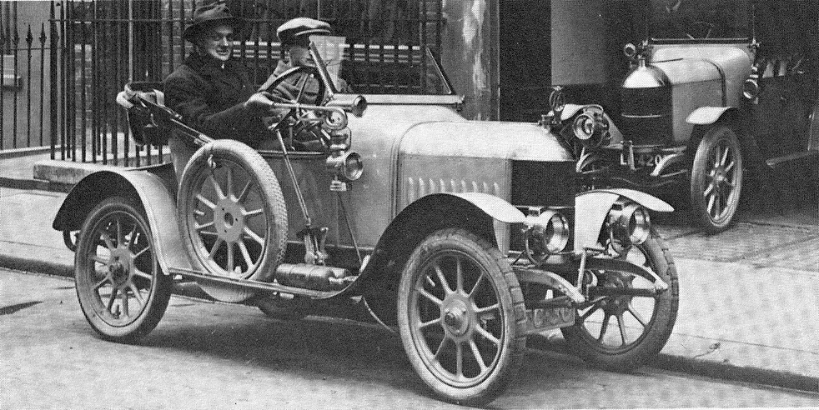  W.R. Morris driving a bullnose Morris Oxford in 1913  Morris Motopolis  - the motor works and the transformation of Oxford  Simon Wenham  William Morris relocated his factory to the eastern suburbs of the city in 1912. He built the first of 154,244 ‘bullnose’ Morris Oxfords in the following year. His business became the biggest car producer in the country in the interwar period, which had a massive impact on the area. Population increased significantly. Oxford became an industrial city, and the university and local hospitals were presented with a major, if sometimes difficult, donor. Cowley turned from a village into a suburb and the British small car became affordable to a wider population. This talk will explore the ways in which Oxford was transformed and the legacy of BMC.  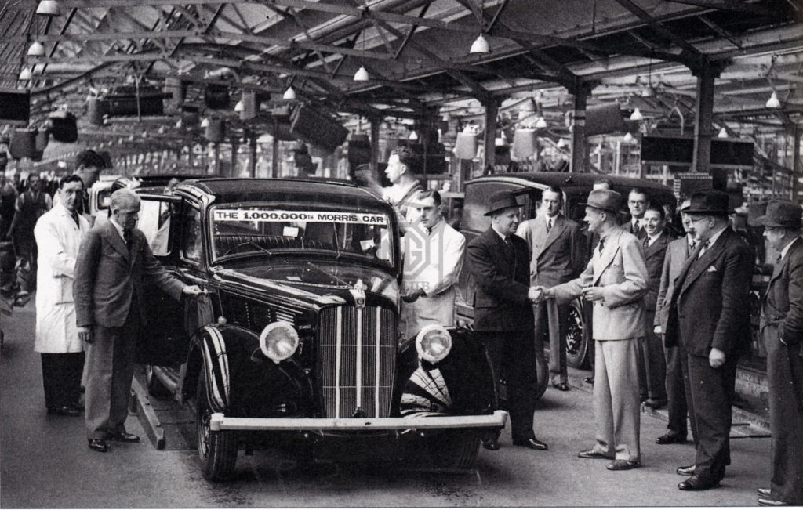  The Millionth Morris leaves the line - 1939 |  | Hanney History Group  8.00 p.m Tuesday 23rd February Zoom Meeting  On your laptop  or computer  Logging In is Easy!  See letter for fuller instructions.  Visitors [£3 per lecture] are welcome.  LOG IN  M  Lord Nuffield’s Spire

