IS THIS WALTER GIFFARD’S MILL POND?

I was recently asked by a member of West Hanney Parish Council if I knew why a triangular piece of land alongside the Letcombe Brook, just south of the East Hanney parish boundary, is part of West Hanney parish. What follows is speculation but it is possible that the explanation dates back over nine hundred years to the turbulent time following the Norman invasion of 1066.

The area in question adjoins the footpath which skirts the Letcombe brook between Bradfield Grove Farm and Dandridge’s Mill. It is an overgrown piece of land which I have heard referred to by longtime residents of the villages as the Wilderness and which is said to have been a popular site for summertime picnics in years gone by.

At its narrow, upstream end there is an old derelict stone bridge across the brook, the downstream end is rather wider and the overall position and shape suggest that, at one time, it may have been a millpond, with a dam across the brook, which has subsequently become silted up. My theory is that this may have been the site of the mill referred to in the Domesday book has having been seized by Walter Giffard, the Lord of West Hanney, from the manor of Charlton.

The Domesday book of 1086, the inventory of land holdings commissioned by William the Conqueror shortly before he died, records enormous amounts of information about most of the counties of England. For example, the Berkshire section tells us that there were three manors or estates in East Hanney, the largest of which was held by Abingdon Abbey, and two in West Hanney, both held by Walter Giffard. There were 61 heads of household in East Hanney and 40 in West Hanney, including Thorold the priest. Historians usually assume that an average Domesday household was around 5 people giving a population estimate of 300 for East Hanney and 200 for West Hanney.

There were three Walter Giffards, father, son and grandson who held land in West Hanney. The first Walter Giffard I (1015-1084) was one of duke Williams henchmen, he was Lord of Longueville in France and is said to have furnished the invasion fleet with 30 vessels and 100 men. Some sources allege that he was implicated in the mutilation of King Harold’s body after the disastrous defeat. Like others of the Norman hierarchy, he was amply rewarded in the post-conquest division of spoils and, in addition to substantial estates in Buckinghamshire, he was given lands in nine other counties, including Berkshire.

Walter Giffard II (1066-1102), created Earl of Buckingham in 1097, was in charge of the family estates at the time of the Domesday survey. From local evidence he, and probably his father before him, appear to have been in the habit of throwing their weight around as typical Norman robber barons. Domesday Book tells us that at Lyford he had suborned the loyalty of the tenants of Abingdon Abbey while at West Hanney he wrongfully held a mill belonging to the neighbouring manor of Charlton. Evidence of this usurpation has been given by the Hundred court, the local assembly of village representatives. Perhaps significantly, there is no mention of similar thuggish behaviour on his core holdings in Buckinghamshire where, no doubt, he held a tighter grip and his tenants would be less likely to complain.

Despite the ambitious claims by some property owners that a building on their site is “mentioned in Domesday” this is virtually impossible to show since locations are not given in the document. Five mills are recorded in East Hanney and two in West Hanney. All that we can be certain of is that they were water driven and located on water courses since windmills, together with rabbits and fallow deer, were only introduced later by the Norman invaders. We can be reasonably certain that one of the East Hanney mills was in the vicinity of the present day Marcham mill as an Abingdon Abbey charter of 956 puts Wulfmaer’s mill somewhere in this area, a location which would have allowed it to serve the Abbey’s estates both at Marcham and East Hanney. Venn Mill is also in a likely position for an early mill, just below the confluence of the Letcombe and Childrey brooks. The locations of the other mills are more problematic but one at our site is a distinct possibility. Although the area is now part of Grove Parish, Grove is not mentioned in Domesday and is probably included under the entry for Charlton.

Walter Giffard III, the grandson, (died 1164) was more interested in his estates back home in France and it was he who gave much of his West Hanney holdings to the priory of Newton Longville, which rebuilt West Hanney church in around 1160, some of the fabric of which still remains in the north west corner of the present church. The lands were seized by Henry V in 1415 when he supressed the alien (i.e. foreign, particularly French) priories and were subsequently given to New College Oxford in 1442 by Henry VI. A map of the New College Estate in West Hanney dated 1779, clearly shows our possible mill pond as belonging to the college, although no building is shown.

So we have a mill usurped by Walter Giffard from the people of Charlton, a possible mill site in about the right location to have belonged to Charlton and an outlying part of West Hanney dating back to 1779 and probably much earlier. Is our site Walter Giffard’s mill pond stolen from the people of Charlton in the 11th Century?

Paul Sayers
Hanney History Group Newsletter Spring 2006
Revised with additional maps and images January 2017

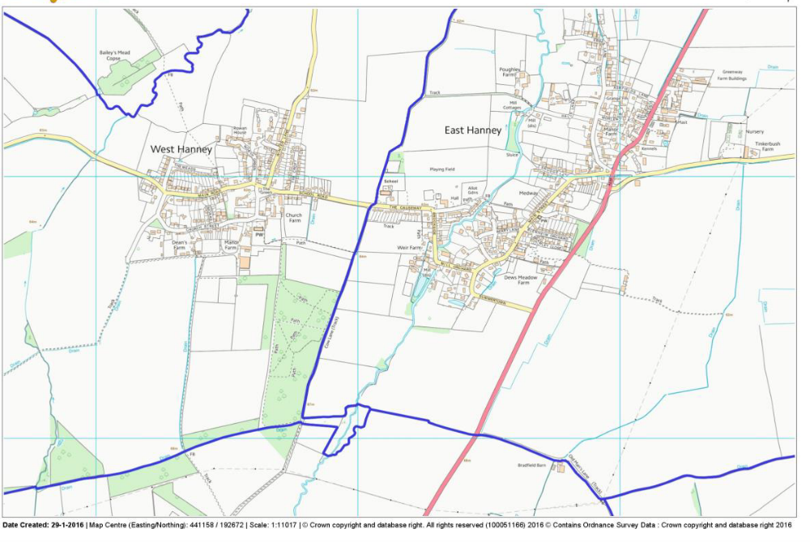
OS map showing location of the site and parish boundaries.
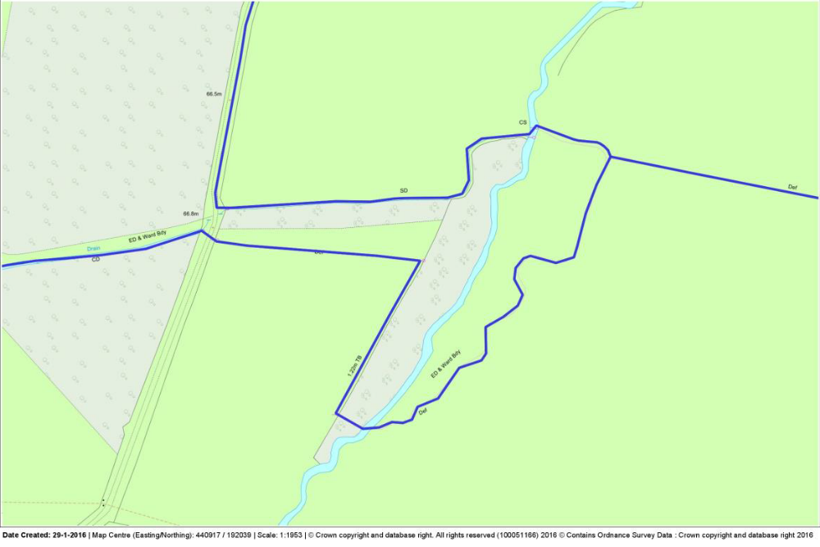
Detail of the site.

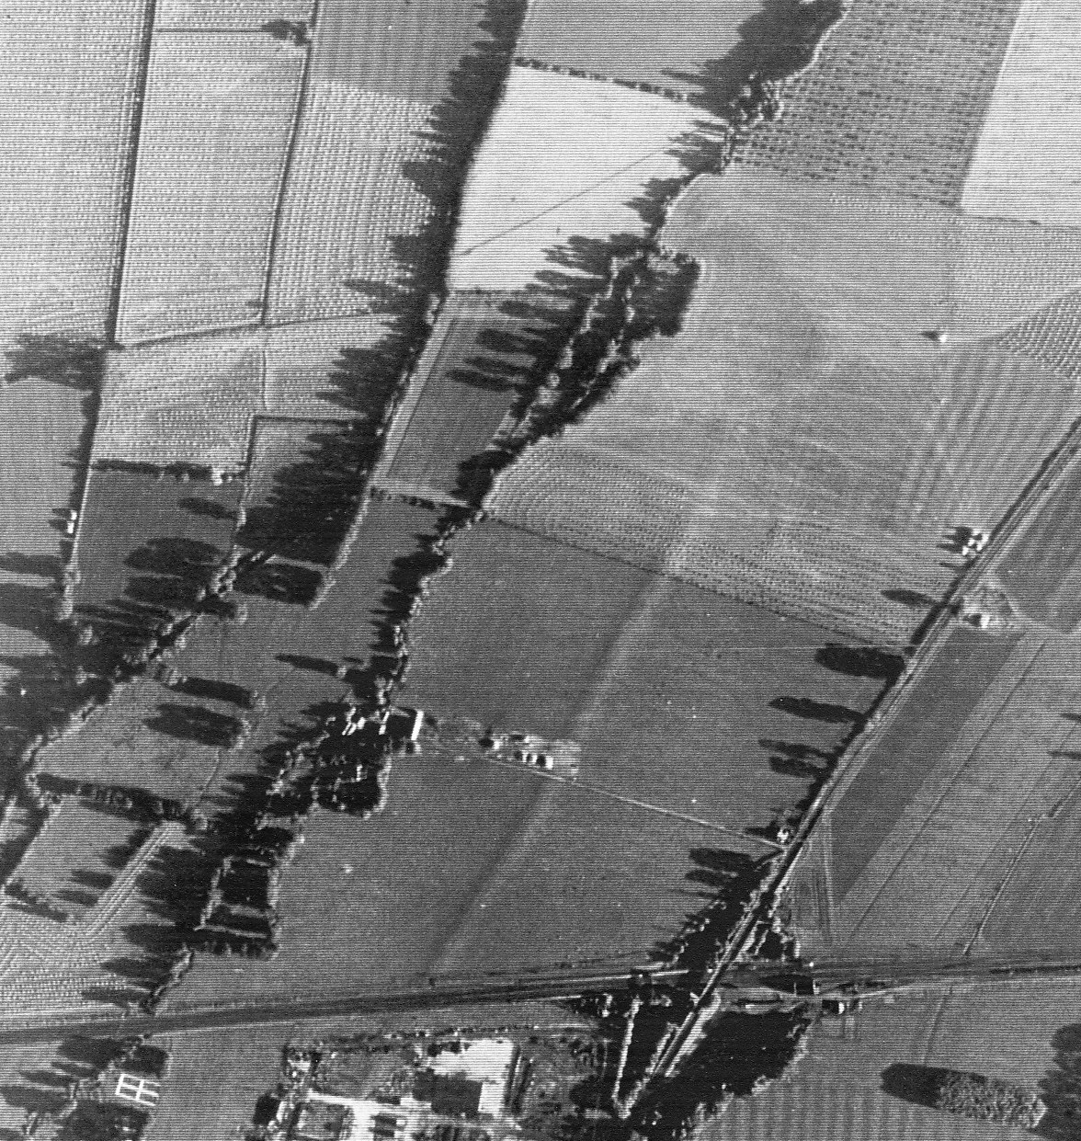
Aerial photograph dated 6:09:1946.
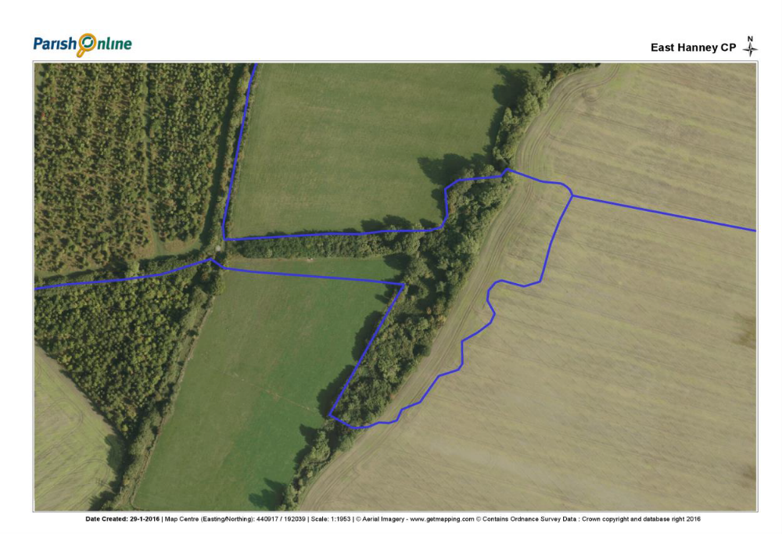
Google Earth image dated 30:05:2009. On the east bank of Letcombe Brook the pond area has been converted to arable.

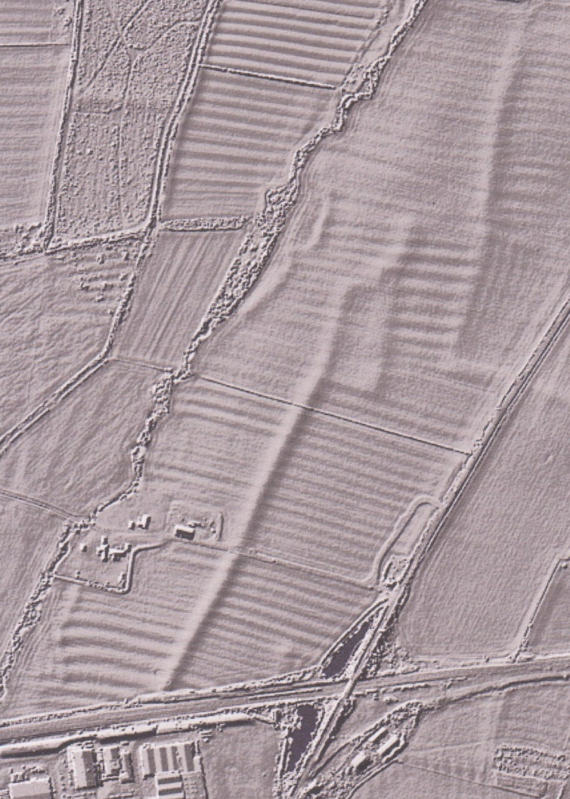
LIDAR image c.2010 still showing the full pond outline

