Appendix 3: East Hanney Listed Buildings
- EAST HANNEY GREEN STREET
SU4193 (East side)
12/24 Nos.1 and 2 The Green
GV II
Two houses. Probably mid C17. Rendered plinth; small timber-framing with painted
brick and rendered infill; thatch roof; old plain-tile roofs to left and right
ends; brick end stacks, ridge stacks to left and right of centre. Single storey
and attic; 6-window range. Plank doors to left and right of centre. Irregular
fenestration of casements. 4 swept dormers to central range. Gabled dormers to
left and right ends. Interiors not inspected.
Listing NGR: SU4193293115

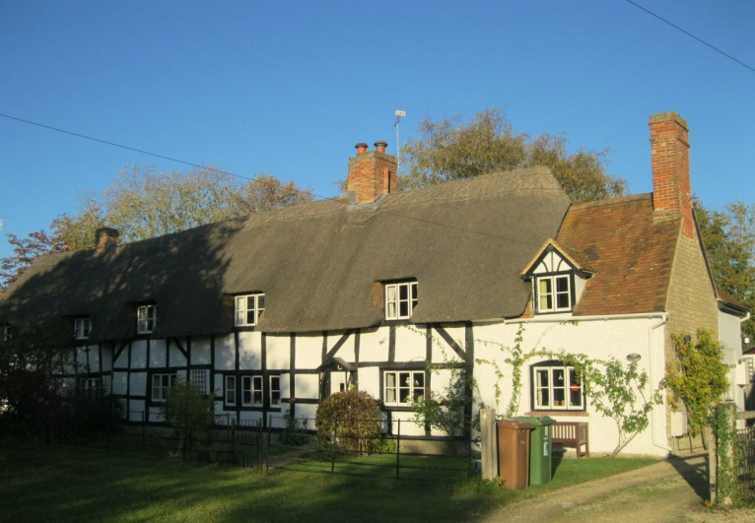

- EAST HANNEY GREEN STREET
SU4193 (West side) 12/27 Barn and cart shed approx. 2m NW of The Grange
6V II
Barn. Probably late C17, with later alterations. Stone uncoursed rubble plinth;
large timber-framing with weatherboarding; C20 plain-tile roof. 4-bay barn.
Garage door to right of centre. Irregular fenestration of C19 windows. Rear, to
garden; right portion converted to dwelling in C19. Interior: queen past roof,
with some wind-braces. Cart shed to right: large timber-framing with
weatherboarding; thatch roof, hipped to right. Openings to rear.
Listing NGR: SU4189193288

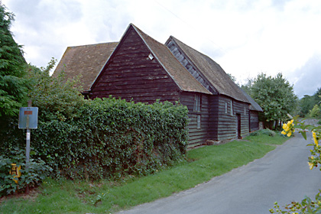
- EAST HANNEY HALLS LANE
SU4193 (North side)
12/32 Barn approx. 25m E of
Philberd's Manor
GV II
Barn. Probably mid C18. Red brick with flared headers in Flemish bond; old
plain-tile hipped roof. 5-bay aisled barn. Gabled midstrey to centre with double plank doors and having dovecote to gable. Ventilation slits to left and right. Interior: double queen-post roof.
Listing NGR: SU4176293304

- EAST HANNEY HALLS LANE
SU4193 (North side)
12/30 Barn approx. 5m W of Varlins
(not included)
GV II
Barn. Probably C17. Stone uncoursed rubble plinth; weatherboarding, probably on timber-framing; thatch roof. 6-bay barn. Plank double doors to right of centre.Irregular fenestration of C19 windows. Interior not inspected. Included for group value.
Listing NGR: SU4189793303

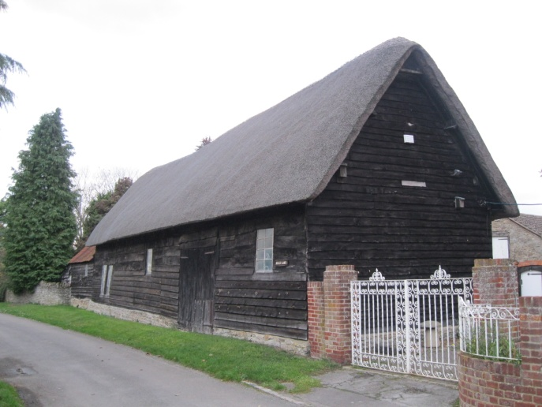

- EAST HANNEY MAIN STREET
SU4192 (East side)
14/34 Chapel Cottage
GV II
House. Probably mid C17, with C20 addition to left. Rendered plinth; small
timber-framing with rendered infill; render, probably on brick, to left; thatch
roof, half-hipped to right; brick ridge stack: to left of centre. Single storey
and attic; 3-window range. Plank door to right of centre. Irregular fenestration
of C20 wood casements. 3 swept dormers with 2-light casements. Interior not
inspected.
Listing NGR: SU4167592829

- EAST HANNEY GREEN STREET
SU4193 (East side) 12/25 Cruck Cottage
GV II
Cottage. C16, with C19 alterations. Coursed stone rubble; thatch roof,
half-hipped to right, with old plain-tile area to left; brick ridge stack to
left of centre. Single storey and attic; 2-window range. 2 plank doors to left
of centre. 3-light wood casements to left and centre. 2-light wood casement to
right. C19 gabled dormers to left and centre with old plain-tile roofs. Left
return; base-cruck frame to wall. Interior not inspected.
Listing NGR: SU4194293083

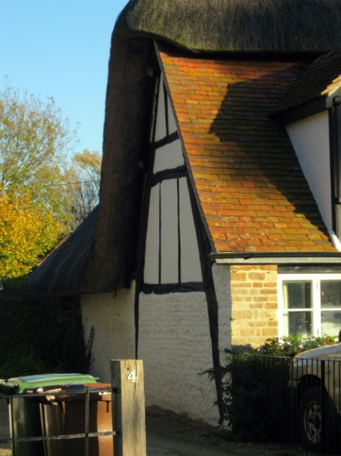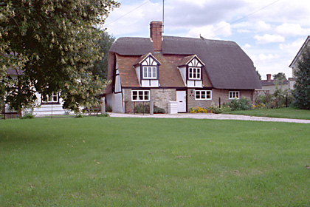

- EAST HANNEY GREEN STREET
SU4193 (East side) 12/21 Grange Farmhouse
24/11/66
GV II
Farmhouse, now house. C18 front, probably to C17 structure, with C19
alterations. Lined render, probably on brick; old plain-tile roof; C20
plain-tile roof to cross-wing to right; brick ridge stacks to centre, and to
cross-wing, end stack to left. 2-storey, 3-window range with cross-wing to
right. 6-panel door to centre with reeded wood surround and flat hood on
brackets. 16-pane unhorned sashes to all openings, except 12-pane unhorned sashes to end of cross-wing. Interior not inspected.
Listing NGR: SU4193993272

- EAST HANNEY GREEN STREET
SU4193 (West side) 12/28 King's Farmhouse
GV II
Farmhouse, now house. C17, with C19 addition to right, and C20 addition to rear.
Painted brick; old plain-tile roof; brick end stack to left, ridge stack to
right of centre. 2-storey, 3-window range. C20 plank door to gabled porch at
left of centre. 3-light casements to ground and first floors left and centre.
2-light casement to ground floor right. Interior not inspected.
Listing NGR: SU4188193160

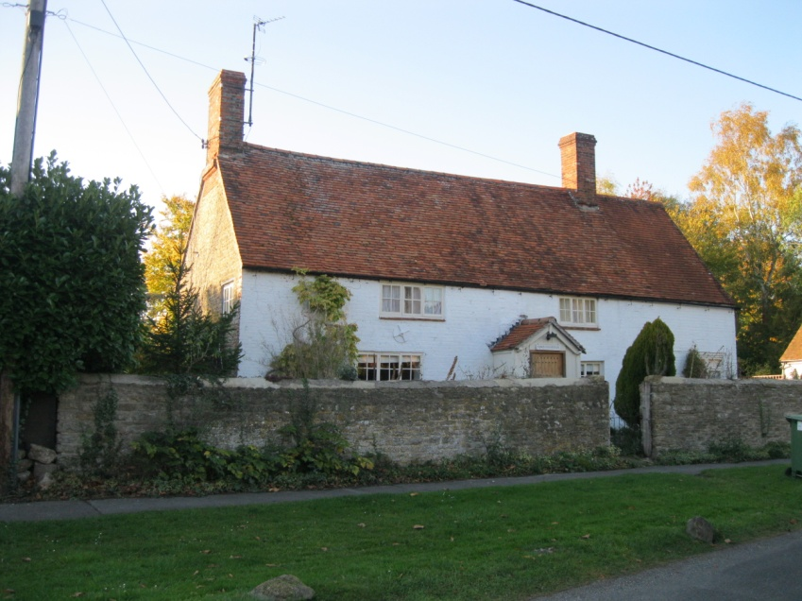

- EAST HANNEY MAIN STREET
SU4192 (West side) 14/36 Lilac Cottage
II
House. Probably early C18. Coursed stone rubble plinth; red brick, with some
timber-framing; thatch roof, half-hipped to left, hipped to right; brick ridge
stack to centre. Single storey and attic; 3-window range. C20 two-light
casements to ground floor. 3 gabled dormers with old plain-tile roofs and
surrounds. C20 door to right return. Rear: timber-framed with rendered infill.
Interior: queen-post roof; chamfered spine beams and open fireplaces to ground
floor.
Listing NGR: SU4162592810
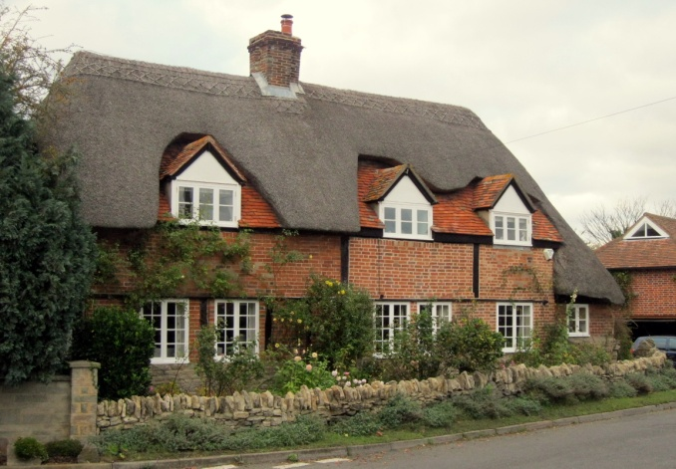

- EAST HANNEY GREEN STREET
SU4193 (East side)
12/22 Manor Farmhouse
GV II
Farmhouse, now house. Probably mid C17, with C19 alterations. Roughcast,
probably on stone rubble; C19 plain-tile roof, half-hipped to right; brick end
stack: to left, ridge stack to right of centre. 2-storey, 5-window range. 6-panel
part-glazed door to left of centre with C19 trellis-work porch. Regular
fenestration, mostly of 3-light wood casements with plain rendered surrounds.
Interior not inspected.
Listing NGR: SU4193293190

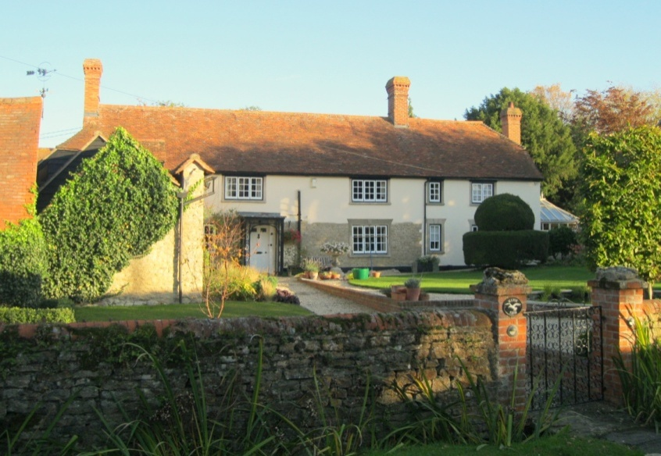

- EAST HANNEY A338
SU49SW (East side) 4/19 Milestone at SU 4152 9217
II
Milestone. Probably early C19. Painted stone. Square. Inscribed "Oxford 11,
Wantage 3".
Listing NGR: SU4152092170

- EAST HANNEY A338
SU49SW (West side) 4/20 Milestone at SU 4230 9357
II
Milestone. Probably early C19. Painted stone. Square. Inscribed "Oxford 10,
Wantage 4".
Listing NGR: SU4230093570

- EAST HANNEY MILL ORCHARD
SU4192 (South side) 14/42 Mill approx. 10m SE of Old Mill House
GV II
Mill. Dated 1820 with C20 addition to left over mill race. Red brick; slate
hipped roof, with lead ridges; brick stack to rear. 3-storey, 9-window range.
6-panel door to right with flat hood. 2-panel door to left of centre with
segmental brick head and flat hood on brackets. C19 metal factory windows havingglazing bars, with cambered brick heads to all openings. Interior:central valleyis supported on 3 storeys of cast-iron columns, the lower 2 storeys a doublecolonnade. Little machinery remains. 3-storey, single-bay, C20 addition to leftin same style. Now converted into three flats.
Listing NGR: SU4128692653
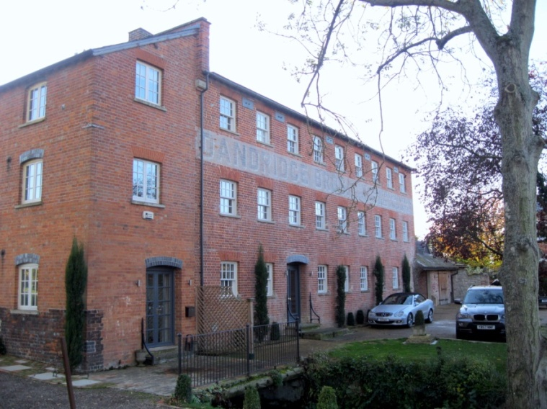

- EAST HANNEY
1708/0/10003 BERRY LANE
08-JAN-02 (Northeast side) Nightingale Cottage
II
Cottage, C18 with early-C19 re-work and addition. Brick walls with low thatched roof. Wooden casements. Tile roof to one-room addition.
PLAN: One-and-one-half storey. Central entrance to longitudinal passage. Two main rooms to each floor in original house, and small one-room addition from early-C19 to north. Central stack.
ELEVATION: Main elevation to west: Central entrance with segmental-headed doorway with plank door, flanked by segmental-headed windows (triple to north and single to south) and an early-C19, triple round-headed window. First floor with symmetrical pair of sashes in eyebrow dormers. One-room addition with pair of casements under hipped roof.
INTERIOR: Chamfered spine beam. Early-C19 fitted cupboards. Brick floor

- EAST HANNEY MILL ORCHARD
SU4192 (South side) 14/41 Old Mill House
GV II
Mill house, now house. Early C19, with mid C19 addition to right. Red brick;
slate hipped roof; brick internal stack to right return. 2-storey, 3-window
range. 6-panel door to centre with decorative fanlight and fluted half-column
surround. 12-pane unhorned sashes to all openings. 2-storey, single-bay additionto right in same style. Interior not inspected.
Listing NGR: SU4126592680

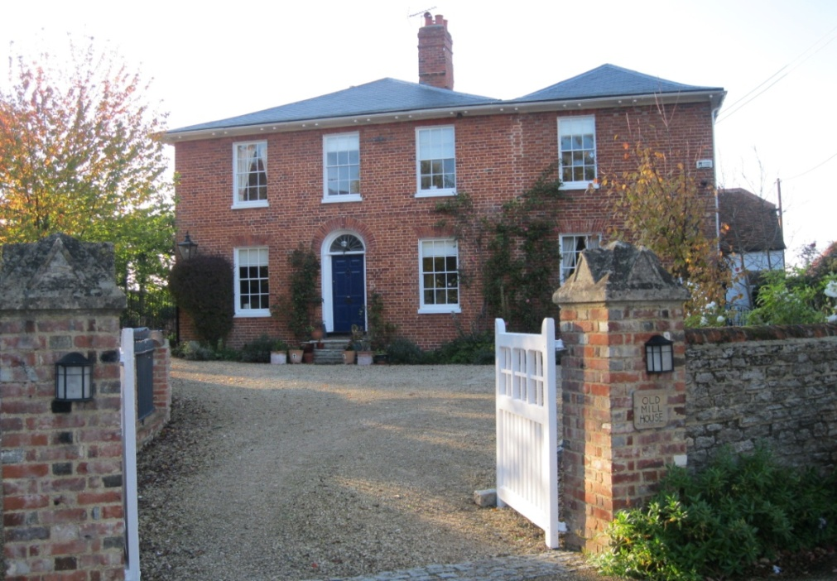

- EAST HANNEY HALLS LANE
SU4193 (North side) 12/31 Philberd's Manor
24/11/66
GV II
House. Mid C18, with early C20 alterations and additions. Red brick with flared
headers in Flemish bond; old plain-tile double-depth roof; various brick stacks.
Double-depth plan. 2-storey, 4-window range with cross-wing to left. 6-panel
door to left of centre with flat hood on brackets. 16-pane unhorned sashes to
all openings. Interior not inspected.
Listing NGR: SU4171393296
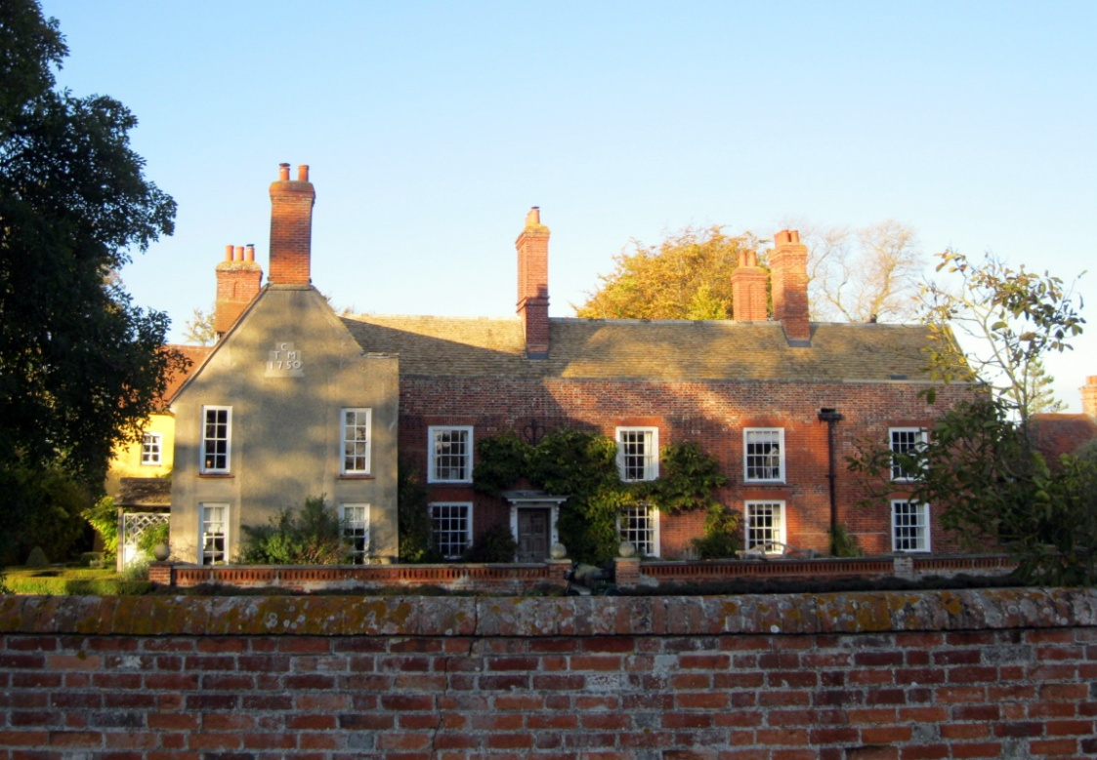

- EAST HANNEY A338
SU49SW (East side) 4/18 Pound Croft House
II
House. C17, with later alterations. Roughcast, probably on brick with painted
quoined dressings; stone slate roof; brick ridge stack to centre. 2 storeys and
attic; 4-window range. C19 ribbed and studded part-glazed door to left of centre
with flat hood on brackets. 3-light casements with hood moulds to all openings,
except 2-light casement with hood mould to first floor left of centre. Gabled
dormer to left of centre. Roof catslides to right. Interior not inspected.
Listing NGR: SU420279309

- SNUGGS LANE
SU4193 Pryor House 1708-0/12/10000
II
House. Circa C17, possibly a remodelling of an earlier house; altered in circa C18 and extended in C20. Timber-framed, 1nfilled and partly rebuilt in brick; roughcast gable ends.
Plain tile roof with gabled ends. Brick axial and gable-end stacks. PLAN: 2-room plan, possibly with central cross-passage, now blocked; the left [E] room is heated from a gable-end stack. In the C18 the frame was partly rebuilt in brick. A wing was added at the rear of the right end in the C20 and later in the C20 another extension was built at the left[E] end. EXTERIOR: 1-storey and attic. Asymmetrical 5-window north front; the left part timber-framed with tension-brace and brick infilling, the right part Flemish bond brick. C20
1,2,and 3-light casements with glazing bars; over the left bay a weather boarded gable. Set back on left end C20 timber-frame and brick extension with a porch in the angle. The main roof at the rear is carried down over a verandah between the C20 wing on the left and the later extension on the right. INTERIOR: The central room has deeply chamfered axial beam with large step stops and a large gable-end fireplace with chamfered stone jambs anda renewed lintel. Right hand room has roughly chamfered axial beam without stops. Central partition has jowled post and glazed panel exposing wattle-and-daub infill. Tie-beam roof trusses with collars, staggered and through purlins and common rafter couples.
Listing NGR: SU4167993027

- EAST HANNEY MILL ORCHARD
SU4192 (North side)
14/40 Railings and gate approx. 10m
S of Robey House
GV II
Railings and gate. Early C19. Red brick plinth to railings; cast-iron railings with spear-head finials and matching central gate. Approx. 1.5 metres high and 15 metres long. Gate signed "C. Hart, Maker, Wantage". Included for group value.
Listing NGR: SU4142892648
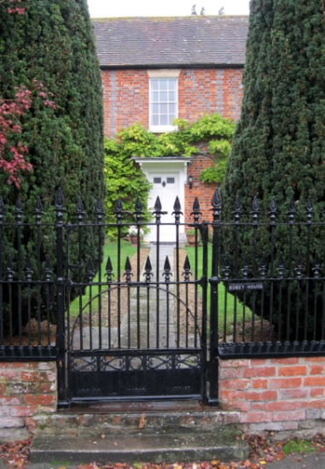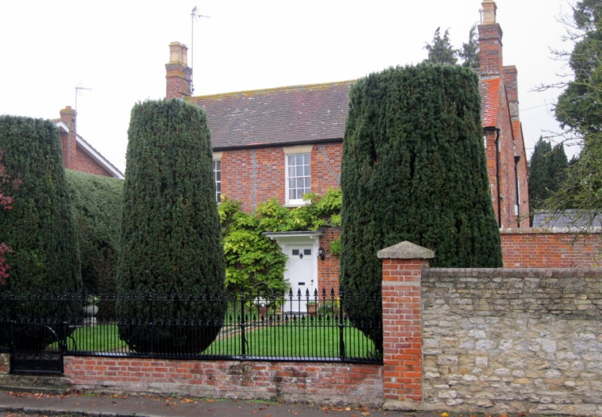

- EAST HANNEY MILL ORCHARD
SU4192 (North side)
14/39 Robey House
GV II
Shown on 0.S. Map as Robey Villa. House. Early C19 front range with possibly C18-rear range. Red brick with flared headers in Flemish bond; old plain-tile roof; brick end stacks. Double-depth plan. 2-storey, 3-window range. 6-panel part-glazed door to centre with reeded wood surround and flat hood on shaped brackets. 16-pane unhorned sashes with stone flat arches, having keystones to all openings, except 12-pane unhorned sash with stone flat arch, having keystone to first floor centre. Interior not inspected.
Listing NGR: SU4143692662

- EAST HANNEY MILL ORCHARD
SU4192 (South side) 14/43 Shelter shed approx. 10m NW of Old Mill House
GV II
Shelter shed. C18. Timber-framed with weatherboarding to rear; corrugated
metal-sheet hipped roof. 2-bay sheltershed. Queen-past roof. Included for group
value.
Listing NGR: SU4125192703

- EAST HANNEY GREEN STREET
SU4193 (East side) 12/23 Stable approx. 10m NE of Manor Farmhouse
GV II
Stable. Probably mid C18, with some C19 rebuilding. Coursed stone rubble plinth; brick, old plain-tile roof. Single-storey, 3-bay range. Plank door to centre
with wood lintel. Openings to left and right with segmental brick heads. C20
window to left return. Interior: Fragmentary remains of feeding rack. Included
for group value.
Listing NGR: SU4194793200

- EAST HANNEY MAIN STREET
SU4192 (West side) 14/35 Sunnybank
GV II
House. C17 house, with C16 cross-wing. Stone uncoursed rubble plinth; roughcast, probably on timber-framing to main block; small timber-framing with rough cast infill to cross-wing; thatch half-hipped roof to main block; fish-scale tile roof to cross-wing with plain-tile edging; stone rubble ridge stack to centre of main block; brick ridge stack to cross-wing. 2-unit lobby entry plan with cross-wing. Single storey and attic; 2-window main block range with door to centre of main block with flat hood. C20 glazed door to left return of cross-wing. Irregular fenestration of casements. 2 swept dormers to main block. Attic gable end of cross-wing is jettied. Interior not inspected.
Listing NGR: SU4165992854

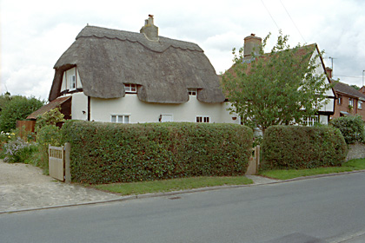

- EAST HANNEY MAIN STREET
SU4192 (West side) 14/37 The Cottage
II
House. Probably late C17. Large timber-framing with painted brick infill; thatch roof; brick ridge stack to centre. 2-unit lobby-entry plan. Single storey and attic; 2-window range at right-angles to street. C20 part-glazed door to centre. C20 two-light wood casement to left. C20 three-light wood casement to right. Right return, to street: C20 casements to ground floor and attic. Interior not inspected.
Listing NGR: SU4157992738
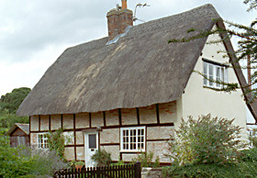
- EAST HANNEY GREEN STREET
SU4193 (West side) 12/26 The Grange and attached
24/11/66 railings.
GV II
House. C17, encased C18. Red brick with flared headers in Flemish bond; C20 plain-tile roof, half-hipped and with catslide to right; brick ridge stacks to
centre and to right of centre. 2-storey, 2-window central range with cross-wing
of 2 storeys and attic to left and single bay to right with catslide to ground
floor. 6-panel door to centre with pediment-gabled hood. 3-light casements with leaded lights and segmental brick heads to central range. 3-light casement with leaded lights to right. Blind panels with segmental brick heads to ground floor end of cross-wing. 2-light casements with leaded lights and segmental brick heads to right return of cross-wing, and to left return of catslide portion to right. Flat brick band between ground and first floors. 2-light casements tofirst floor and attic of cross-wing. Rear: lined render, probably on stone rubble. Right return: gable end and lean-to have stone slate tiles. Interior: C18 half-domed niche to ground floor centre rood with pilastered surround, shaped shelves, and cupboard under. Early C19 cast-iron railings and central gate with spear finials form entrance court.
Listing NGR: SU4190793274
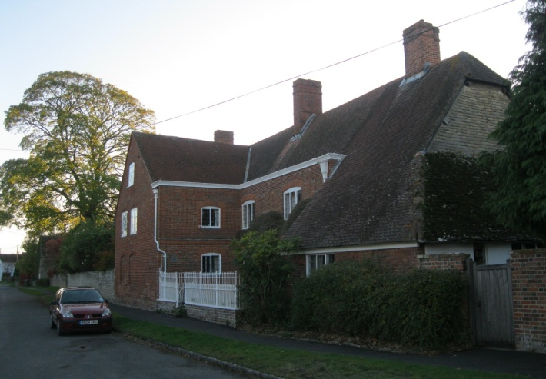
- EAST HANNEY MAIN STREET
SU4192 (West side) 14/38 The Mulberries
08/09/86
II
House. Late C18 front to probably earlier structure, with early C19 two-bay
addition to left. Red brick; slate roof; brick end stacks. 2-storey, 3-window
range. C19 panelled and part-glazed door to left with flanking lights, having
rectangular flat-roofed porch on painted Doric columns. 12-pane unhorned sash to ground floor centre with rendered flat arch, having keystone. C20 flat-roofed angled bay to right with horned sashes. 12-pane unhorned sashes to first floor with rendered flat arches, having keystones. 2-storey, 2-bay addition to left: red brick; slate roof hipped to left. 12-pane unhorned sashes with rendered flat arches, having keystones, to all openings except C20 flat-roofed angled bay to ground floor right with horned sashes. Interior not inspected.
Listing NGR: SU4149292688
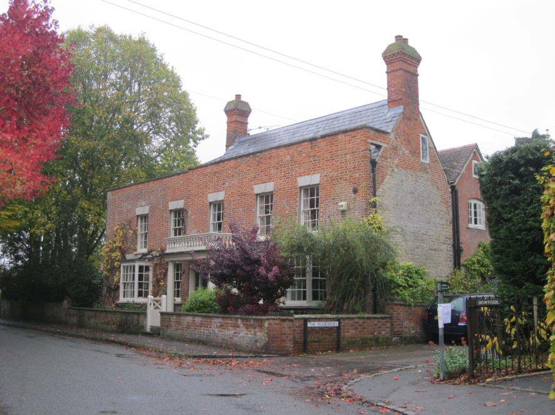

- EAST HANNEY Brookside
SU4192 14/17 Weir Farmhouse and attached small barn
II
Farmhouse. Probably early C17, with mid C18 front, and later alterations. Red
brick with flared headers in Flemish bond; C20 plain-tile roof; massive
stone-rubble ridge stack to centre; brick lateral stack to rear. Single-storey
and attic; 4-window range. Plank door to left of centre. Panelled door to
centre. Irregular fenestration of casements. Gabled dormers. Rear: lined render,
probably on timber-framing. Interior not inspected but noted as having chamfered
spine beams to ground floor. Small barn attached at right-angles to right.
Probably C18. Stone rubble plinth; weatherboarding, probably on timber-framing;
corrugated sheet metal roof. 2-bay barn.
Listing NGR: SU4128492763

28 Orchard Cottage, Summertown SU 413925
House, originating in the C17, with a C19 extension.

Description
House, originating in the C17, with a C19 extension.
MATERIALS: red and buff brick, roughly coursed and rubble limestone, with clay-tiled roofs, brick stacks, and timber or metal-framed windows.
PLAN: a linear plan with four bays of two storeys, orientated E-W.
EXTERIOR: the principal elevation faces S and is made up of two distinct sections: on the W the three bays of the original building, denoted by the chimneystacks, and on the right (E) the two-storey C19 extension. Windows and doorways to the earlier part of the building have red brick surrounds, with segmental arched brick lintels on the ground floor, and meeting the eaves on the first floor. The front door is a historic ledge and plank construction, with a glazed insertion; it sits beneath a timber porch with a tiled roof. Windows are irregularly sized and spaced with a variety of casements, many of which are modern replacements. There is a brick stack at the junction between the central section and the W extension (excluded from the listing), and the gable appears to have been built out around this in stone. The C19 extension to the E uses buff brick or dressed stone details, rather than red brick. It is a single bay and follows the line of the roof of the original building. A chimney emerges at the junction, external to the earlier building. It has a modern stable door.
The rear, N elevation is built mainly in roughly coursed rubble stone, without the brick enrichments found on the S. It has four irregularly sized and spaced windows, one of which has a segmental brick arch.
The sunroom to the E is modern, and has the 1689 date stone set in its plinth. The single-storey extension on the W dates from circa 1985. Both are excluded from the listing.
INTERIOR: there are two rooms to the ground floor of the original building, with a central stair between them. The front door opens into the room to the W, which has a thick, deeply chamfered spinal beam and axial joists with prominent carpenter’s marks. The end wall, containing the fireplace is in modern brick and has a historic timber inserted part-way up. A winder stair leads to the first floor. The room to the E also has a thick axial beam which is chamfered and has moulded stops; it is ceiled beneath the joists. There is a modern stone chimneypiece, lined in brick and with a reused timber forming a mantel shelf.
The E extension has a large hearth in modern materials. There are no notable historic features.
The stair is lit by a first-floor window, and has a recess to a blocked opening on the ground floor.
The roof of the earlier part of the building is supported on three queen post trusses. These are ceiled at the collar, and the central one infilled to create a partition between two main rooms; a modern partition has been inserted between the stair and the main bathroom. The tie beam of the central truss bears the scar of an inserted doorway; a modern doorway sits within a wider cut. The first-floor room of the E extension does not contain notable historic features. In the loft there is lath and plaster partitioning and partial covering to the rafters.
Pursuant to s.1 (5A) of the Planning (Listed Buildings and Conservation Areas) Act 1990 (‘the Act’) it is declared that the sun room attached to the E and 1985 extension attached to the W are not of special architectural or historic interest.

History
Orchard Cottage stands on a site which has been under occupation since the Roman period, and may be the site of the lost Manor of Southbury. A date stone, alleged to have been resited from elsewhere within Orchard Cottage, states ‘WM 1689’. Whilst the origins of the stone are unknown, a C17 date for the building is likely based on its historic fabric.
Orchard Cottage is a multi-phase building which originally appears to have been a three-bay cottage. An extension was made to the E end, and the Ordnance Survey maps published between 1878 and 1912 show the building as three cells, their proportions suggesting use as two separate dwellings. By 1975 it is shown as a single range, and Rowans, the dwelling attached on the N elevation, had been added.
A good collection of joinery survives internally, and alterations to the timber roof trusses illustrate its course of development. Within the loft space there is some lath and plaster surviving on the underside of the rafters, suggesting that it was once open. The stair is likely to date from the C19.

Reasons for Listing
Orchard Cottage, a C17 dwelling extended in the C19, is listed at Grade II for the following principal reasons:
* Architectural interest: a pre-1700 cottage of good-quality construction surviving largely intact, with features and materials suggesting a high status dwelling;
* Interiors: contain good-quality pegged ceilings, a number of historic doors with ironmongery, a C19 stair and the complete roof structure

