Appendix 1: West Hanney Listed Buildings
Listing in the Hanneys
Relatively few listed buildings existed in the Hanneys before a topping up process carried out in the early 1990’s. This was carried out by a sub-contracted external inspection only for the most part and has been criticised both for its superficial nature and its omissions. Some buildings were included for group value and most interiors went uninspected. East Hanney church, a G.E.Street building of historical and group significance, albeit a little bland, is unlisted. So too are Lower Mill, an imposing brick mill of some historical and industrial interest, and the Fontana Restaurant. This neglect has helped the latter to be modified into a motel like structure enclosing a Tudor core. The whitewashing of the Black Horse pub, an excellent blue and red brick inn, has already been mentioned and this was a clear example of a building that should have been at least included for group value. The chapel could perhaps be added to this category too.
A positive outcome of the listings is the large number of buildings that have some protection. Awareness of the good vernacular core of the villages has been raised and there is perhaps scope, even as a result of this project, for others to be added to the list. In terms of stone, the assessors seem to have been biased towards these buildings, apart from the church and chapel in East Hanney. This is of course a reflection on the age, significance, size and architectural merit of these often slightly grander stone buildings, many of which would have been created for the middle class professionals of their day . Many of the cottages, sheds and even milestones are however the exceptions to this generalisation and thankfully survived the planning neglect and benevolent improvers of the post war period.
The lists included below are verbatim transcripts from the English Heritage list. The photographs were mostly taken by the Hanney History Group in the autumn of 2011, with the exception of 2, 5 and 23 in the West Hanney list and 2, 23 and 24 in that for East Hanney. A number of historical views from the Taunt and Frith collections have been added for contrast and an insight in a more peaceful world which may of course have camouflaged some alternative ills and neglects to those we face today.
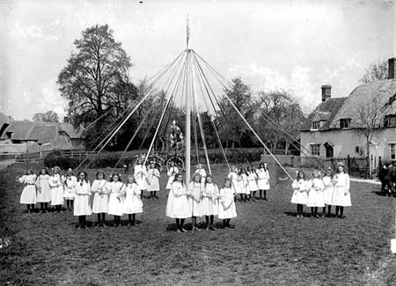

- WEST HANNEY CHURCH STREET
SU4092 (South side) 13/160 Barn and stable approx. 10m N of Church Farmhouse
GV II
Barn and stable. Probably mid C18. Stone coursed rubble with brick dressings;
stone slate roof to barn at left; old plain-tile roof to right; single-storey,
5-bay range. Double plank doors to left of centre. Plank door to right of
centre. 2-light openings with segmental brick heads to right and centre, having
wood louvred frames. Roof half-hipped. Interior not inspected. Included for
group value.
Listing NGR: SU4068492878
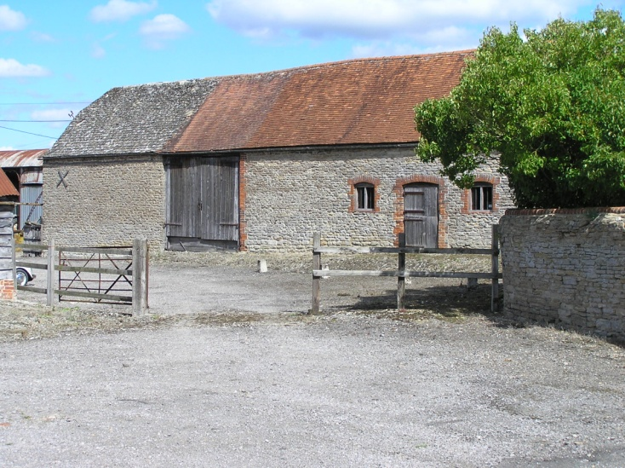

- WEST HANNEY POST OFFICE LANE
SU4093 (East side)
11/168 Barn approx 10m NW of Rectory
16/05/84 Farm Cottages
(Formerly listed as Barn North
West of Rectory Farm Cottages)
GV II
Barn. Probably early C18. Large timber-framing with weather boarding; C20
interlocking tiles to half-hipped roof. 3-bay barn. Central doorway, and
opposing door to rear, both with doors missing. Queen post roof with wind
braces, most common rafters survive. Included for group value.
Listing NGR: SU4060993090
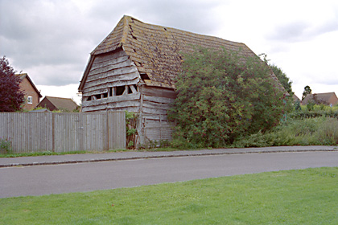

Barn prior to conversion

- WEST HANNEY MAIN STREET
SU4092 (North side)
13/166 Carter's Close
II
House. C17. Irregular timber-framing with painted brick and rendered infill;
thatch half-hipped roof; stone ridge stack to left of centre with C18 brick flue
attached to left; brick end stack to right. Single storey and attic; 3-window
range. Plank door to C20 porch at right of centre. Irregular fenestration of
casements. Swept dormers with 3-light casements, having leaded lights. Interior not inspected.
Listing NGR: SU4046392976

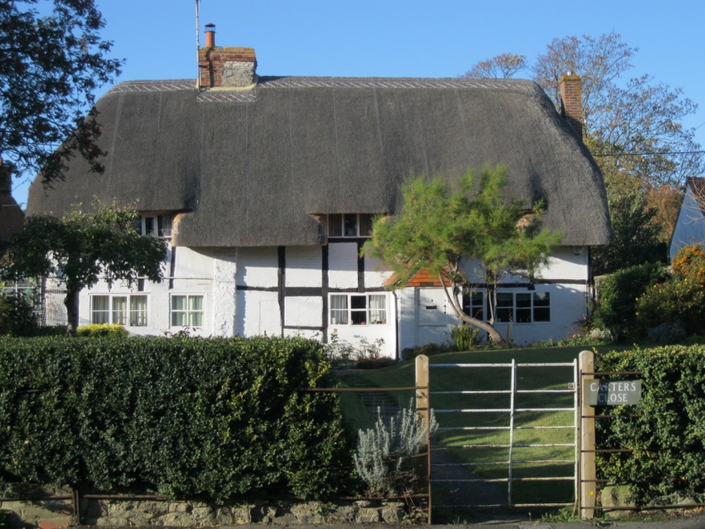

- WEST HANNEY WINTER LANE
SU4092 (East side)
13/177 Castle Acre
II
House. C17, with later alterations. Coursed stone rubble; stone slate roof;
brick ridge stack to right of centre. Probably 2-unit lobby-entry plan with
cross-wing to left. 2-storey, 2-window range with cross-wing to left. C20 door
to right of centre with C20 open porch. Irregular fenestration of C20 casements. 2 raking dormers with C20 casements. Left return and rear of timber-framing with rendered infill. Interior not inspected.
Listing NGR: SU4067792978
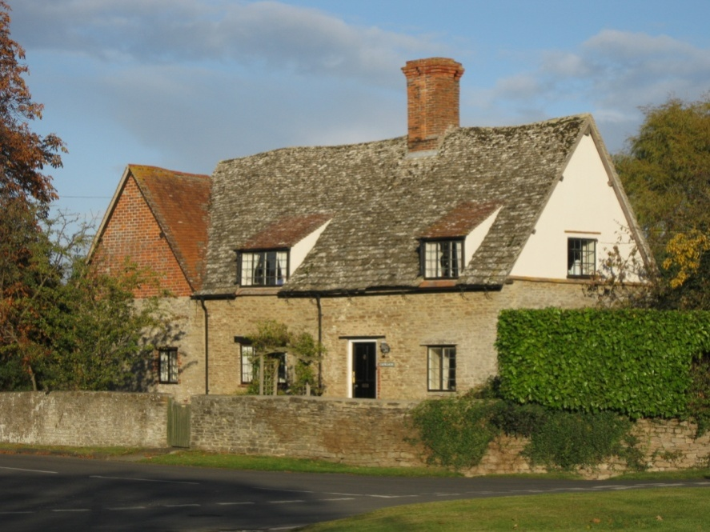

- WEST HANNEY CHURCH STREET
SU4092 (South side)
13/163 Chest tomb to William Woodward
approx. 2(in S of transept of
Church of St. James
GV II
Chest tomb. Dated 1725 to inscription. Stone. Rectangular. Cyma-recta moulded
plinth. Plain central panels to each side and end. Baluster mouldings to
corners. Shaped edge to plain top slab. Inscription to south-facing panel.
Listing NGR: SU4061992777

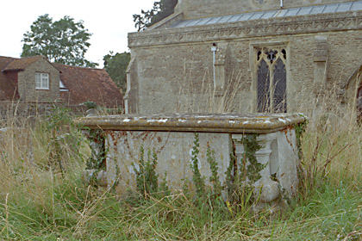

- WEST HANNEY CHURCH STREET
SU4092 (South side)
13/159 Church Farmhouse
24/11/66 (Formerly listed as Church
Farm)
GV II
Farmhouse. C17 with C19 addition. Coursed stone rubble; stone slate roof; old
plain-tile roof to addition; brick ridge stack. 2-storey, 2-window range.
6-panel part-glazed door with hood to left. 16-pane unhorned sashes to all
openings. C19 addition forms cross-wing to left of 2-storey, 2-window range,
with irregular fenestration of casements. Interior not inspected.
Listing NGR: SU4068392857
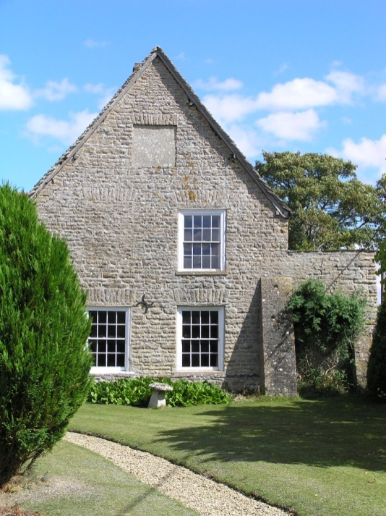

- WEST HANNEY CHURCH STREET
SU4092 (South side)
13/162 Church of St. James
24/11/66
GV II*
Church. Nave c.1150; late tower C12; C13 south transept; C14 south arcade and
aisle, and nave lengthened to west; C15 chancel; C19 restoration, including
raising of nave, addition of clerestory, and porch. Stone uncoursed rubble;
slate roof to chancel and tower, old plain-tile roof to nave and south aisle.
4-bay nave with south aisle and south transept, north tower and 2-bay chancel.
C19 porch to left of centre of nave with 2-centred archway on cluster columns.
Romanesque doorway on spiral columns having dog-tooth imposts and richly carved
arch; C19 plank double doors. 2-centre arched doorway to right-return of tower
with C19 plank door, 4-centre arched doorway with hoodmould to centre of
chancel. Romanesque lancets to centre of nave with some C19 stone work. C19
two-light plate tracery window to left of nave. Two 3-light stone mullion
windows to chancel with arch-topped lights and hood moulds. Romanesque lancet to
tower. South side: 2-centre arched doorway to nave right of centre with stone
hood on brackets. Paired cusped lancets with flat heads to left of centre, and
to right, of nave. C19 fenestration to south transept, including 3-light
geometrical tracery window to south end. 3-light stone mullion windows to
chancel. C19 quatrefoil windows to clerestory. Interior: C19 kingpost roof of
4-bays to chancel. C19 plate tracery windows to west end. 5-light Perpendicular
tracery window to east end of chancel with hood mould. Interior: C19 kingpost
roof of 4-bays to chancel. C19 arch-braced collar truss roof of 8 bays to nave.
C19 scissor-truss roof to transept. C19 lean-to roof to aisle. Piscina to right
of altar. Late C17 altar rail of turned wood balusters. C15 chancel screen with
C19 wood panels to base. 2-centred chancel arch of 2 orders; inner order carried
on three-quarter columns with foliate capitals supported on corbels. C17 wood
hexagonal pulpit to left of chancel screen. Romanesque font on C19 stepped
plinth. Round font has vertical bands of rosettes. South arcade of four
2-centred arches on cluster columns. Fragments of medieval glass to windows of
aisle.
(Buildings of England: Berkshire; 1975, p263: VCH: Berkshire: Vol 4, 1924,
p291-2)
Listing NGR: SU4061992800
19th century view of church with tower, The Plough, Old Post Office, wheelwright’s yard and demolished cottage [on left]
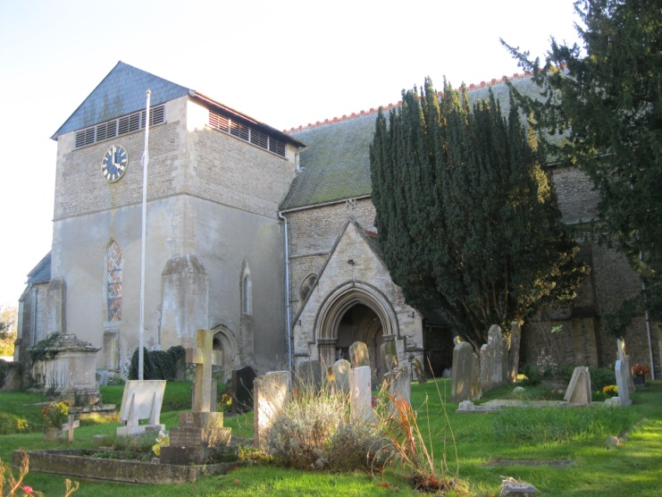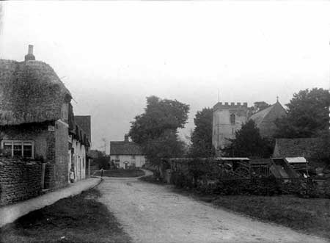

- WEST HANNEY THE GREEN
SU4092 (West side)
13/174 Garden wall approx. 30m S of
West Hanney House
GV II
Garden wall. C18. Stone uncoursed rubble to lower half; red brick with flared
headers in Flemish bond above. Wall forms an L-shape on the East and South sides of the garden. Approximately 3 metres high, each side being approximately 45 metres long.
Listing NGR: SU4060092858

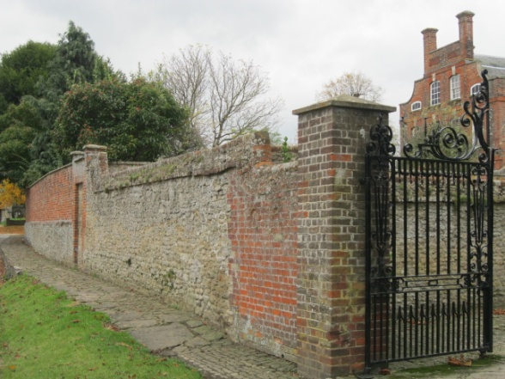

- WEST HANNEY THE GREEN
SU4092 (West side)
13/175 Granary approx.5m NW of West
Hanney House
GV II
Granary. Probably mid C18. Staddle stones; weatherboarding on timber-framing; stone slate half-hipped roof. Single-storey, 3-bay range. Plank door to left return. 3-light wood mullion window to centre. Interior not inspected. Included for group value.
Listing NGR: SU4056292895

- WEST HANNEY CHURCH STREET
SU 4092 (east side)
13/180 Implement shed approx
20 metres to north-west
of Aldworths
II
Implement shed. C18; probably 2nd half, with C19 addition. Timber frame on
rubblestone plinth; horizontal board cladding, that to C18 part of very wide
boards and with cover strips over the joints. Thatched roof. One storey,
4 bays, the right-hand bay an addition and partitioned off from the rest.
Front and left side open, having timber posts on brick plinths with straight
braces to wall plate and tie-beams; right bay has board double door; roof
hipped at left end. Interior: wall posts are sharply jowelled and have
chiselled carpenter's marks; collared queen-post roof trusses with crudely-cut
through purlins; log-like rafters and ridge-piece. Examples of C18 implement
sheds are not common and this is a particularly good-quality one.
Listing NGR: SU4025192876

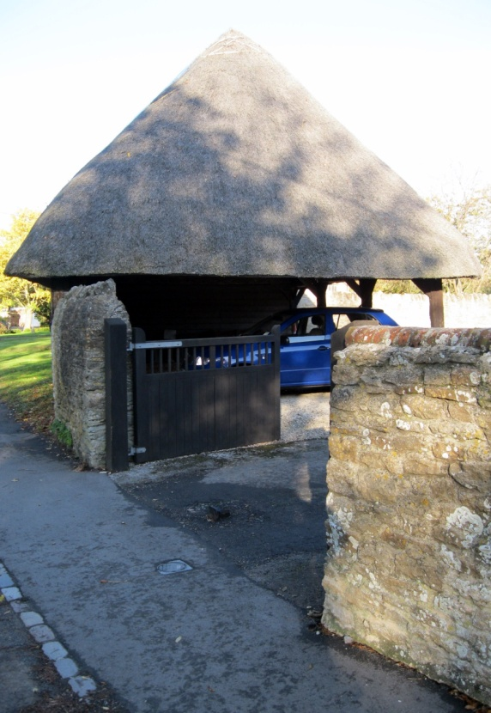

- WEST HANNEY SCHOOL LANE
SU4092 (South side)
13/171 Lamb Cottage
II
House. Probably mid C17. Large timber-framing with painted brick infill; C20
plain-tile roof; brick ridge stack to centre. 2-unit lobby-entry plan. 2-storey.
3-window range. Ribbed door to centre. Irregular fenestration of C20 casements. Double Queen-post roof truss to right-return gable end. Interior not inspected.
Listing NGR: SU4079692921

See illustration in introduction

- WEST HANNEY POST OFFICE LANE
SU4093 (West side) 11/170 Manor Cottage
II
House. C17. Small timber-framing with rendered infill; C20 plain-tile roof;
brick end stacks. 2-storey, 3-bay range. Plank door to centre. Irregular
fenestration of casements. First floor jettied. Interior not inspected.
Listing NGR: SU4056993013
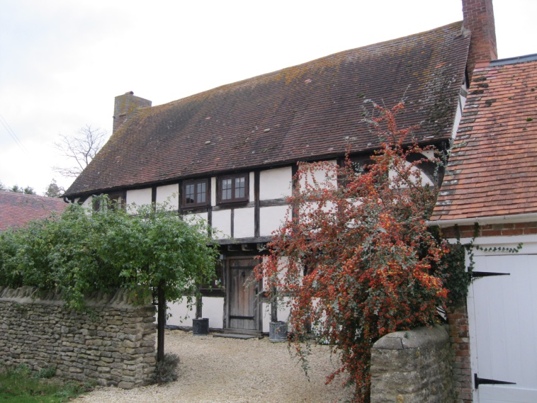

- WEST HANNEY CHURCH STREET
SU4092 (South side)
13/164 Manor Farmhouse
25/10/51 (Formerly listed as Prior's
Court)
GV II
Farmhouse. Probably early C17, with C18 cross-wing, having C20 alterations.
Brick plinth to cross-wing; stone uncoursed rubble; complex stone slate roof;
brick ridge stack to left of centre, and ridge stack to cross-wing. Probably
originally 2-unit lobby-entry plan, now L-plan. 2 storeys and attic; 4-window
range, with 4-window cross-wing of 2 storeys and attic to right.
Single-storey-and-attic gabled porch to left of centre with studded door having
wood lintel. 2-panel door to left of cross-wing, and plank door to right of
centre of cross-wing. Irregular fenestration, mostly of C20 casements, with wood lintels. C17 four-light wood mullion windows to first floor left, and to right
of centre with ovolo-moulded mullions. Cross-gable to left, with 2-light
casement. 2 full, gabled, dormers to cross-wing with 2-light casements. Rear: 2 storeys and attic; 5-window range. 2-panel door to left of centre with flat
stone arch. 2-light casements to all openings, those to first floor having
leaded lights, except C20 fenestration to C20 projecting addition to right. 2
gabled full dormers. Interior not inspected.
Listing NGR: SU4058392780
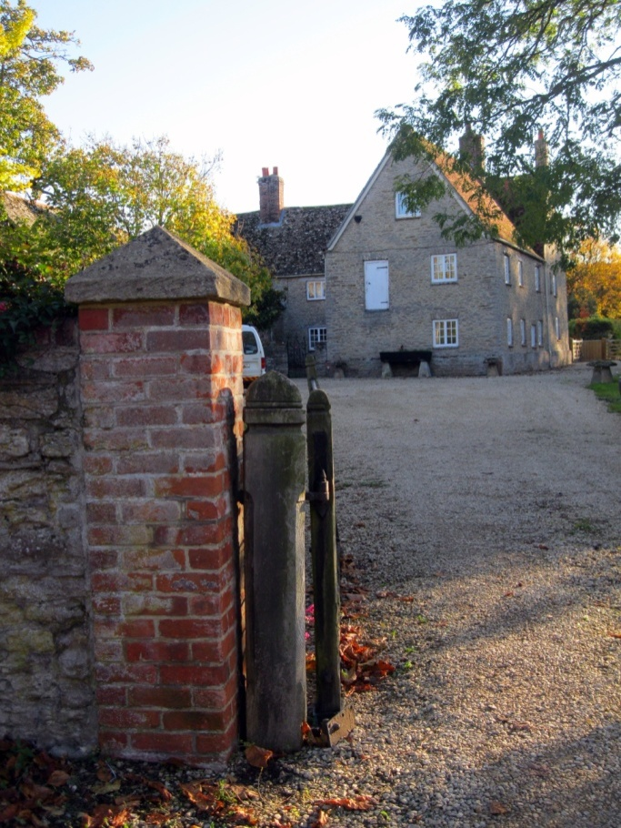

- WEST HANNEY POST OFFICE LANE
SU4093 (West side)
11/169 Old Dunsdons
GV II
House. Early C18. Red brick with flared headers, having ashlar stone bands and dressings; old plain-tile roof; brick end stacks. 2 storeys and attic; 3-window range. 6-panel part-glazed door to centre with stone architrave surround, brick segmental relieving arch, and flat hood on brackets. 3-light stone mullion windows to left and right with stone architrave surrounds, moulded sills, and flush, shaped aprons. Brick segmental relieving arches above windows. Flat stone band between ground and first floors. 3-light stone mullion windows to first floor left and right with stone architrave surrounds, moulded sills, and flush,shaped aprons. 2-light stone mullion window to first floor centre, with stone architrave surround, moulded sill, and flush, shaped apron. 2 gabled full dormers with 2-light casements. Interior not inspected. C20 addition to right, of 2-storey, single-bay range. Included for group value.
Listing NGR: SU4057293027

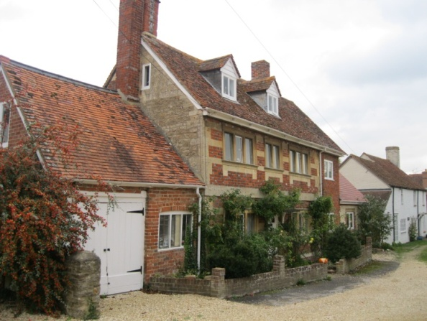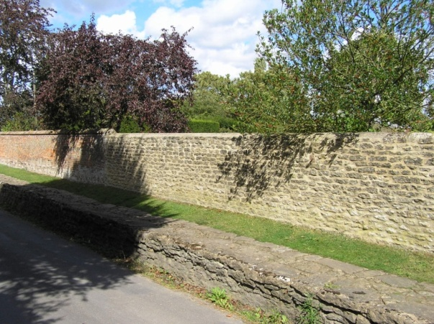

- WEST HANNEY CHURCH STREET – illustrated above
SU4092 (North side)
13/154 Raised footpath
GV II
Raised footpath. Probably C18. Stone uncoursed rubble with stone flags to
surface. Approx. 45 metres long. Included for group value.
Listing NGR: SU4061292881

- WEST HANNEY CHURCH STREET
SU4092 (South side)
13/157 Raised footpath
GV II
Raised footpath. Probably C18. Stone uncoursed rubble with stone flags to
surface. Approx. 50 metres long. Included for group value.
Listing NGR: SU4062092896
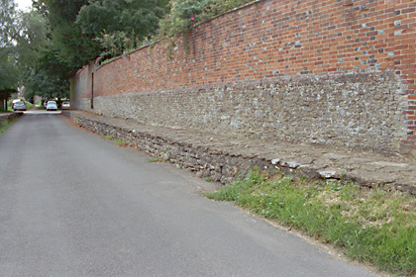
- WEST HANNEY POST OFFICE LANE
SU4093 (East side)
11/167 Rectory Farm Cottages
16/05/84
GV II
Pair of cottages, possibly converted from house. Probably early C18 encased and altered C19. Red brick with flared headers in Flemish bond; old plain-tile roof; brick ridge stack to centre, C19 brick end stack to right. Probably originally 2-unit lobby-entry plan. Plank doors with segmental brick heads to left, and to right of centre. Door to right of centre has C20 brick open porch. 3-light wood casements with segmental brick heads to left of centre, and to right. Grey brick flush band between ground and first floors. Two 2-light wood casements to first floor. Interior not inspected, but reputed to have elements of timber-framing.
Listing NGR: SU4062393074

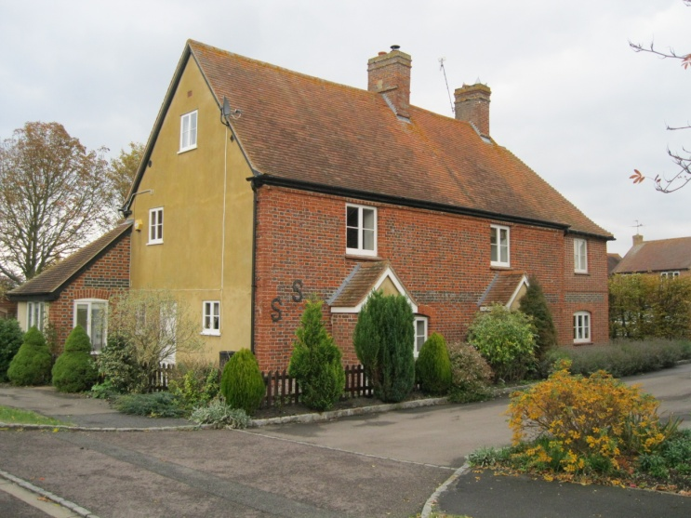

- WEST HANNEY CHURCH STREET
SU4092 (South side)
13/165 Rose Cottage
GV II
House. C17. Render, probably on stone rubble, to plinth; irregular
timber-framing with painted brick infill to ground floor; irregular
timber-framing with rendered infill above; thatch half-hipped roof; stone ridge
stack to centre with C18 brick flue attached to right side. Single storey and
attic; 3-window range. Irregular fenestration of 2-light casements. 2 swept
dormers with 3-light casements. Left return: C20 glazed door with C20 open
porch. Interior not inspected.
Listing NGR: SU4027892784
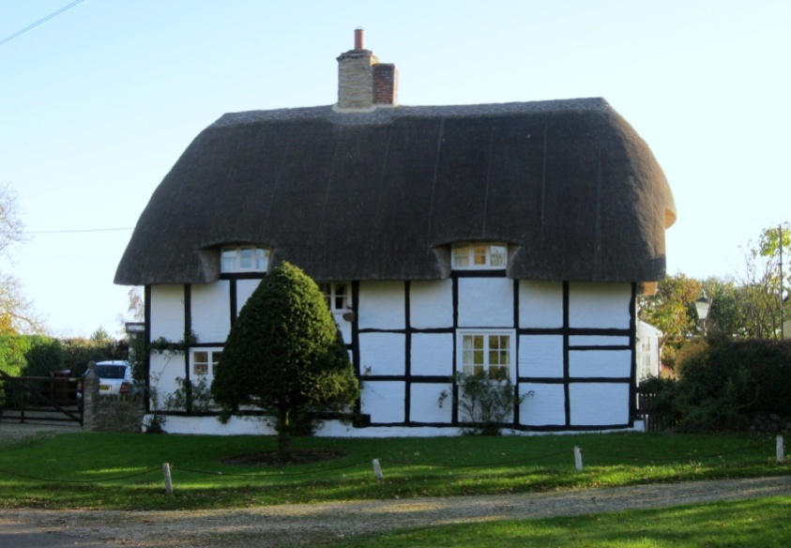

- WEST HANNEY CHURCH STREET
SU4092 (North side)
13/156 Sheperd's Cottage
GV II
House. Probably early C18. C19 brick plinth; large timber-framing with rendered infill; thatch half-hipped roof; brick end stack. Single storey and attic;
2-window range. C20 door to centre with C20 open porch. C20 three-light metal casements to left and right. Swept dormer to left with 3-light wood casement. Interior not inspected.
Listing NGR: SU4034192807

- WEST HANNEY THE GREEN
SU4092 (West side)
13/176 Stable block approx. 30m NW of
24/11/66 West Hanney House
(Formerly listed as Stable
Block at West Hanney House)
GV II
Stable block, part now converted to garages. Early C18, with later alterations.
Coursed stone rubble; stone slate roof. Single storey and attic; 9-window range. Stable doors to left and to left of centre. Garage doors to centre. Plank door to right of centre. Irregular fenestration of casements and openings with
louvred woodwork. Gabled dormers. Hay dormer to left of centre. 2 glovers to
centre and to right, that to centre having weathervane. Interior: feeding rack
to left. Date stone of 1838 to centre.
Listing NGR: SU4055192919

- WEST HANNEY CHURCH STREET
SU4092 (North side)
13/155 The Plough Public House
25/10/51 (Formerly listed as The Plough Inn)
II
Public House. Probably mid C17. Painted brick to ground floor; square
timber-framing above with C20 brick infill; thatch roof; brick end stack to
left, ridge stack to centre. Single storey and attic; 4-window range. Plank door
to left. Irregular fenestration of casements to ground floor left. 4-pane horned
sashes to ground floor right. Eyebrow dormers with 3-light casements. Interior
not inspected.
Listing NGR: SU4056692839

See illustration in introduction

- WEST HANNEY CHURCH STREET
SU4092 (South side)
13/158 The Vicarage
24/11/66 (Formerly listed as Vicarage)
GV II
Vicarage. Probably early C19. Red brick with flared headers in Flemish bond;
stone slate roof; brick end stacks. 2-storey, 3-window range. 4-panel door to
centre with overlight and flat hood on shaped brackets. 12-pane unhorned sashes to all openings with flat brick arches. Flat brick band between ground and first
floors. Worn stone panel above flat brick band to centre. Dentil brick course to
eaves. Interior not inspected.
Listing NGR: SU40629928
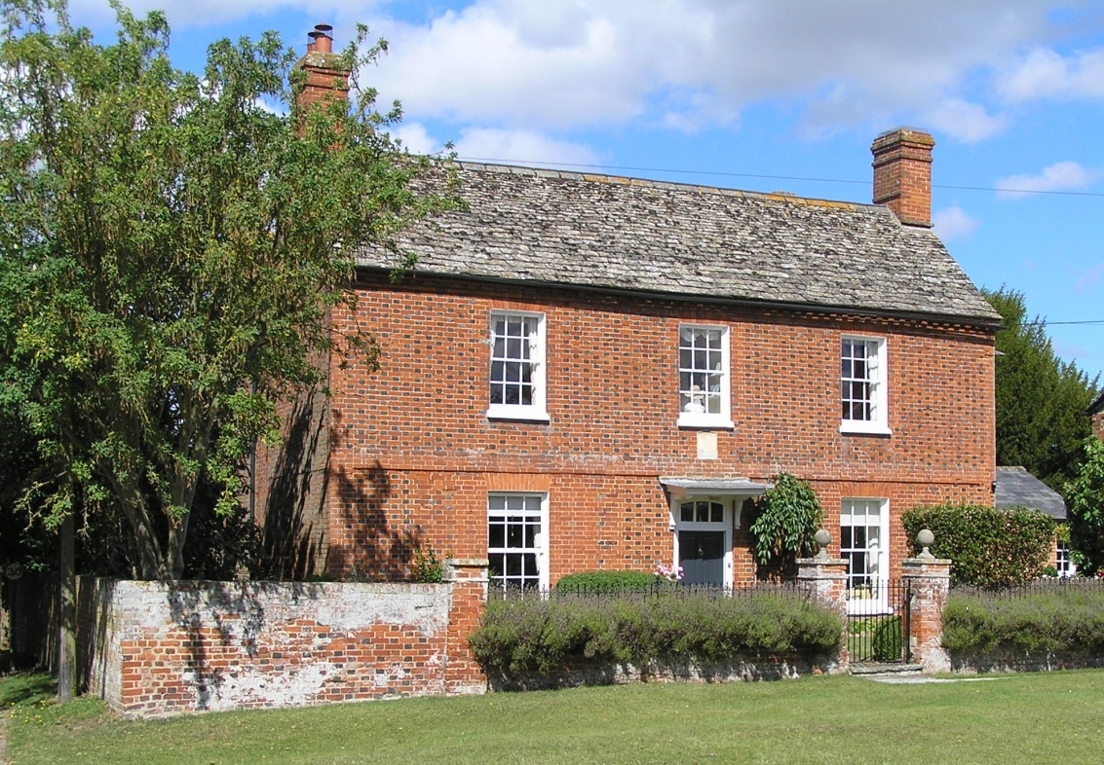

- WEST HANNEY THE GREEN
SU4092
13/172 Village Cross
25/10/51
GV II
Village cross. Re-assembled c.1908, incorporating some C15 stone-work. Stone. Octagonal stepped base. Tapering octagonal shaft supporting square panelled top and cross. Included for group value.
(N. Hammond, The Oxfordshire Village Book, 1983, p176)
Listing NGR: SU4065092944
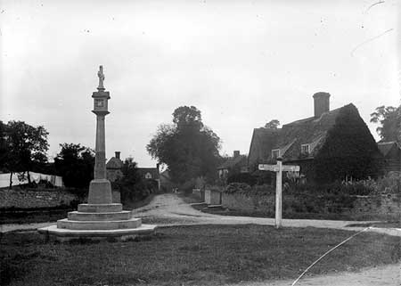

Cross at the turn of the century. All houses in Winter Lane are now demolished apart from Castle Acre to the right.

- WEST HANNEY THE GREEN
SU4092 (West side)
13/173 West Hanney House and attached
25/10/51 archways
(Formerly listed as West
Hanney House)
GV II*
Rectory now house. Dated 1727 on sundial to south front. Red brick with flared headers, with red brick dressings; slate mansard roof; brick lateral stacks and end stacks. Baroque style. 3-storey, 2-bay centre; 2-bay ranges of 2 storeys and attic to left and right. Main front to garden 2:2:2. Centre 2 bays project forward. Sash door to right of centre with overlight and segmental brick head having keystone. Segmental-headed 12-pane unhorned sashes with segmental brick heads having keystones and shaped brick aprons to all openings except false window to third floor right of centre. Flat brick band between ground and first floors. Flat brick band to base of parapet. Panelled parapet, swept up to centre 2 bays. Panelled parapet to centre 2 bays. Lateral stacks flank centre 2 bays. Right return: 3-storey, 2-bay centre; single-bay ranges of 2 storeys and attic to left and right. 1:2:1. Regular fenestration, mostly of false windows. End stacks flank centre 2 bays. Interior: C18 dog leg staircase and panelled rooms. Attached archways to left and right with open pediments.
(Buildings of England, Berkshire, 1975, p263; VCH: Berkshire, Vol 4, 1924, p285)
Listing NGR: SU4058492888
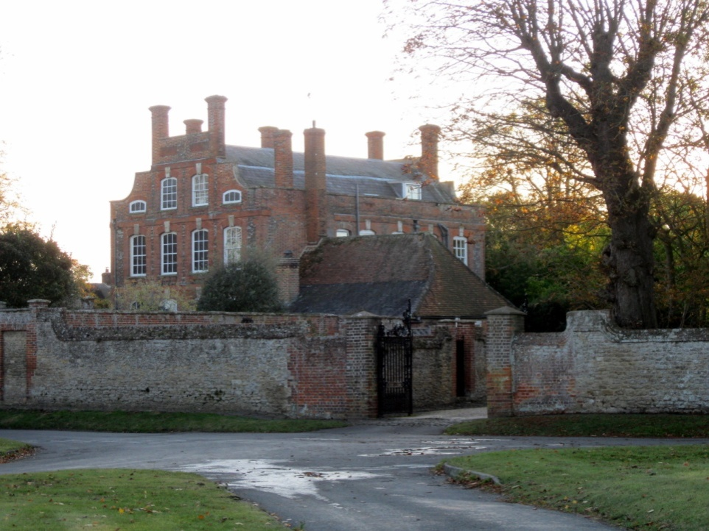

- WEST HANNEY CHURCH STREET
SU4092 (South side)
13/161 West Hanney Post Office
24/11/66 (Formerly listed as Post
Office)
GV II
House, part formerly post office. C17 with C18 alterations. Rough-cast, probably on stone rubble; stone slate to lower portion of roof; old plain-tile to ridge area of roof; massive brick ridge stack to left of centre, ridge stack to right of centre. Probably 3-unit lobby-entry plan originally. 2-storey, 5-window
range. 6-panel door to left of centre with open-pedimented wood surround.
16-pane unhorned sashes to ground and first floors left and left of centre.
2-light casements to ground and first floors right and right of centre. Interior
not inspected.
Listing NGR: SU4065092830

